***C-GASP Level 1 Screener***

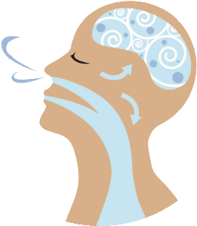

***(Children’s General Airway Screening Protocol)***

***Developed by the***

**Children’s Airway Screener Taskforce (CAST) *committee of the ADA***

**\*\*\**Optimizing Pediatric Airway Health\*\*\****

**For children ages 2 through 12**

**Please complete the entire questionnaire in order to address health related issues for your child.**

**DATE _________ Dr. Name _____________________________________________________________**

**Child’s Initials: ______ Gender (circle): Male / Female Child’s Birth Date: __________**

**Relationship to child: Mother❏ Father❏ Guardian❏ Other❏_______ Child Age ___ years ___ months**

**Please complete this form by checking “Yes”, “No”, or IDK (“I Don’t Know”) for each question.**

**YES NO IDK**

**DOES YOUR CHILD FREQUENTLY HAVE ANY OF THE FOLLOWING:**

**1. Mouth Breathing / Lips Apart either while Awake or Asleep? ................................**

**2. While sleeping or napping: Snore (even slightly) / have Noisy Breathing /**

**Difficulty Breathing / Pauses or gasping during Breathing? ...................................**

**3. Neck Extended Upwards when Sleeping / Restless Sleep / Frequent Awakenings /**

**Grinding or Clenching Teeth during Sleep? ..............................................................**

**4. Upon wakening: Dry Mouth / Sore or achy Jaw / Headaches / Stuffy Nose /**

**Difficulty Awakening in the Morning? .....................................................................**

**5. Daytime Sleepiness or Tiredness / Daily Behavioral or Emotional Issues /**

**Difficulty paying Attention / Hyperactivity / Difficulty at School? .........................**

**6. How hard was it to complete this form? (please check) Easy Average Difficult**

**If difficult why? ___________________________________________________________________________**

**7. How much time did it take to complete this form? (please check)**

**2 minutes or less 3 – 5 minutes 6 – 10 minutes 11 – 15 minutes**

***CGASP Level 1 screener - Ver 5.0 05-12-2021***